WHEREAS, the Saint Mary’s University of Minnesota (SMUMN) Student Senate is vested with the authority to be the voice of the student body and,

WHEREAS, the Student Senate is vested with the authority to utilize surplus funds from previous Student Activities fee monies to conduct capital improvements on the Winona Campus and

WHEREAS, the water bottle filler will provide easy access for students in the residence hall of LaSalle

THEREFORE, BE IT RESOLVED, that the Student Senate allocates $1700 for a water bottle filler

BE IT FURTHER RESOLVED, that the Student Senate shall be given the final renderings of the approval; and,

BE IT FURTHER RESOLVED, that the university departments working on this project keep the Student Senate informed of necessary decisions and deadlines in a timely manner, with the understanding that the ultimate authority over the project is under the direction of the Student Senate.

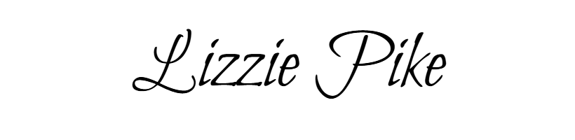
______________________________
Maggie Newhouse
President
_______________________________
Lizzie Pike
Vice President of Administrative Affairs

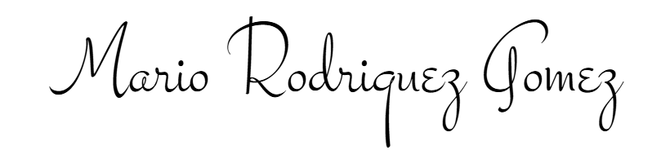
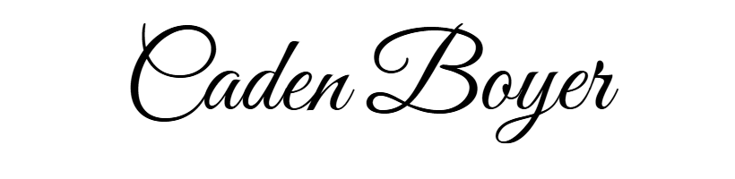
______________________________
Mario Rodriguez-Gomez
Vice President of Campus Affairs
______________________________
Caden Boyer
Vice President of Public Affairs

